Garrett Phillips

Dr. Long

Marketing 4480

Goodbelly Case Analysis

* **Confirm that the results of the coefficient estimates and inferential statistics are identical in both the R models and the Excel models.** 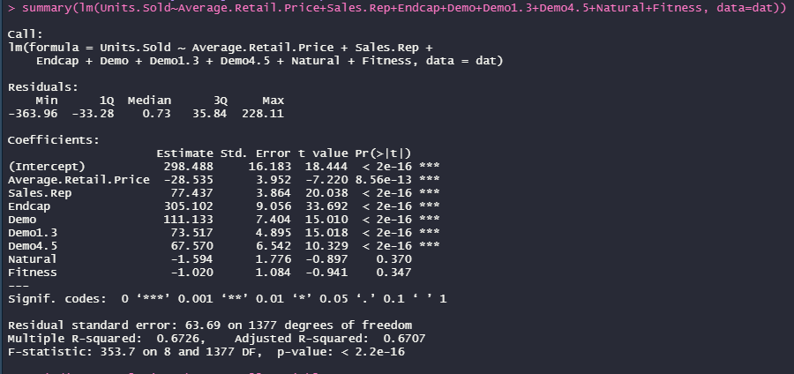

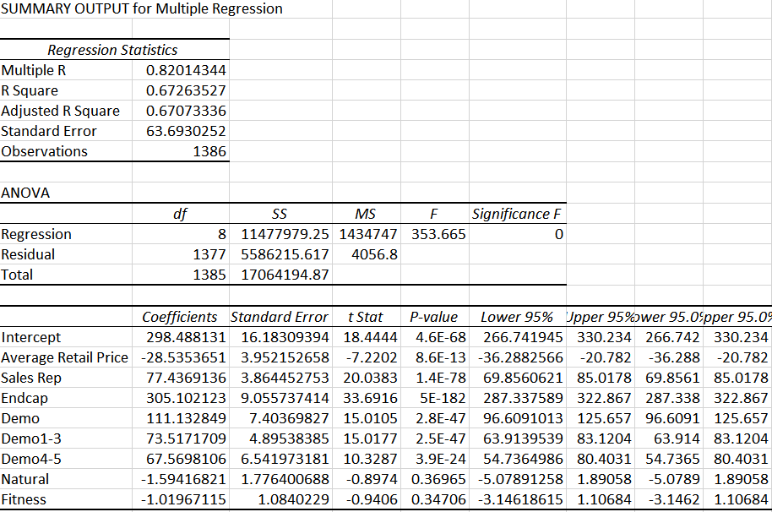

* **Summary Information and coefficient interpretation**
  + Units sold based on price
    - 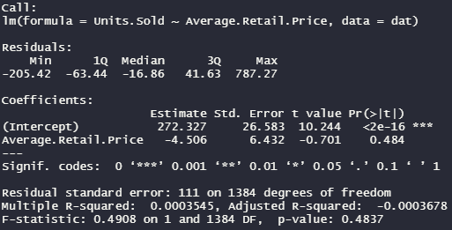
    - With an R-squared of -.000368, I would conclude that sales price has little impact on the units sold. When compared with the multiple regression model, the standard error is halved. This leads me to believe that sales price is a much better predictor with multiple variables rather than on its own. The intercept of 272 is nearly pointless as if the price was free, the company would not produce any products.
  + Units sold based on Sales Representative
    - 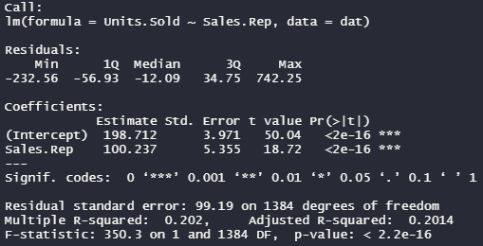
    - With an adjusted R- squared of 0.2014 I believe having a sales representative is the second most important factor in predicting sales volume. Compared to the multiple regression analysis, this analysis has a standard error that is 138% higher. This shows that with additional predictors, sales representative can more accurately predict the sales volume. The y-intercept of 198 represents the average units of sale in stores with no sales representative.
  + Units Sold based on Endcap Display
    - 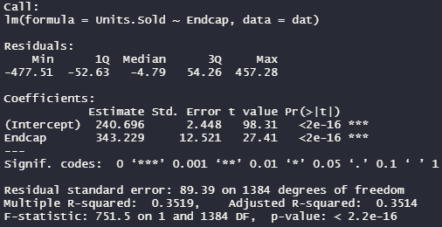
    - The Adjusted R squared (0.3514) is the highest of any of the predictor variables. This shows that End Cap promotional activity has the strongest The adjusted R squared and coefficient are the highest of any variable in the single regression model. This implies it has the strongest correlation to sales units. In the multiple regression, the coefficient drops from 343 to 305, however it remains the most accurate predictor variable.
  + Units Sold based on Demonstrations
    - 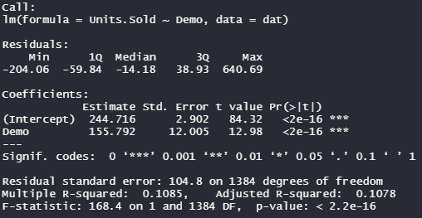
    - The demonstrations do have a positive impact on sales as the result of a store doing the demos increases sale units by 155. The adjusted R squared of 0.1 shows that although the prediction power is low, it is significant. The SSE is 155 which determines that our regression line is a better fit than based off a sales representative, but not as good a fit as that of the endcap display.
  + Units Sold based on Demonstrations (Weeks 1-3)
    - 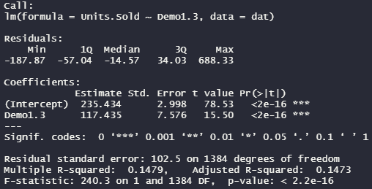
    - Units sold based on in store demonstrations have a relatively high adjusted R squared. Because of this I would determine that demos do have an effect on units sold. The SSE dropped to 117 which determines that our regression line is still a better fit than based off a sales representative, but not as good a fit as that of the endcap display, or that of the previous week of demonstrations.
  + Units Sold based on Demonstrations (Weeks 4-5 )
    - 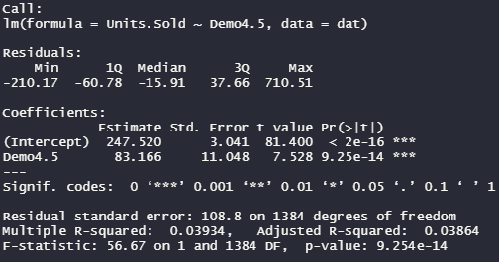
    - The SSE drops again from 117 to 83 in the final week of recorded sales for in store demos. This shows that the effects of the demonstration on sales diminishes over time quite significantly. The adjusted R squared also drops off showing that weeks 4-5 after an in store demo do not strongly correlate with units sold.
  + Units Sold based on Natural
    - 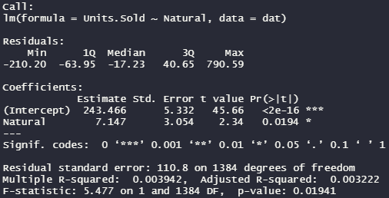
    - With an incredibly small adjusted R squared, an SSE of 7, and a p-val that is less than .05, we can conclude that the variable associated with other natural retailers has little, if any, effect on units sold.
  + Units Sold based on Fitness
    - 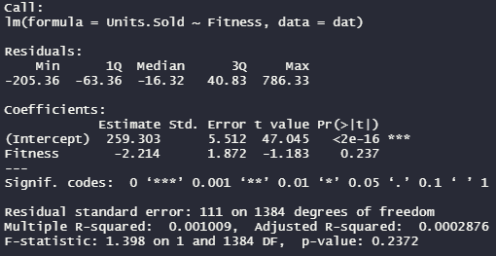
    - Similar to the previous natural variable, the fitness variable does not have an effect on our regression model. The adjusted R-squared of the fitness variable is the lowest of all.
* **Which multiple regressions were substantially different in the multiple example? Which model do you trust more and why?**
  + The biggest discrepancy in my analysis occurred for the natural variable. The coefficient switched from 7.14 to -1.59. I believe the multiple regression analysis was more accurate of the relationship between natural producers in the area and units sold. I believe it is possible that although a weak correlation exists in the singular analysis, the predictor value is wiped by the stronger predictors.
* **Describe the Natural and Fitness variables**
  + The natural and fitness variables both have very weak, if any, effect on the sales volume. Both variables have negative coefficients in the multiple regression, so the numbers should be used to predict other outcome types. One use of this data could be to select the stores that are near fitness centers and specifically track sales based on window displays. I’m not confident that this would provide value to the company as it would be an additional focus on top of the current marketing plans.

**Analysis**

After conducting both single and multiple regression models, I conclude that their promotional actions are improving sales. While all promotion efforts are boosting sales, the endcap display seems to have the strongest impact. As a brand I would be sure to maximize the promotion of the endcap displays. This makes sense to me as when selecting a product of this type visibility is key. The market for natural drinks is growing and many players are joining, so being able to standout at the point of purchase should be Goodbelly’s focus.

The demonstrations are having a positive impact on sales volume, but the effects taper off into the fourth and fifth week. The promotion should be continued as it has a stronger impact on sales volume than that of a local sales representative. It isn’t until weeks 4-5 that the impact of the sales rep outweighs that of the promotion. I would recommend having an in store demo possibly once a month to maximize this promotion’s impact.